

  - Research On Near Field Communication (NFC)
02/2026

Revision History
Revision No. | Description | Editor | Date
1.0 | Document Creation | Didar Ali | 09 Feb 2026
2.0 | Adding the practical application Section | Didar Ali | 26 Feb 2026
3.0 | Real Passive Authentication (ASN.1/CMS parsing + DG hash verification); Chip Authentication attempt via DG14 ECDH; document corrections | Didar Ali | 27 Feb 2026

1. Near Field Communication (NFC) 6
1.1 Introduction 6
1.1.1 Definition Of NFC 6
1.1.2 Applications of NFC technology 6
1.1.3 Working Principle of NFC 6
1.2 NFC – Key Specifications 6
1.2.1 Communication Speed 6
1.2.2 Storage Capacity 6
1.2.3 Operating Range 6
1.3 Core Technologies and Tools in NFC 6
1.3.1 Standards 6
1.3.2 Hardware 6
1.3.3 Tools 6
1.3.4 Software 6
1.3.5 Encryption Keys in NFC 6
2. NFC Based ID cards and Passports 6
2.1 Introduction 6
2.1.1 Why NFC-Based ID Cards & Passports Are Used 6
2.2 Standards and Terminologies 6
2.2.1 Standards 6
2.2.2 Terminologies 6
2.3 How NFC-Based ID Cards and Passports Work 6
2.3.1 Data Storage in the Chip 6
2.3.2 Data Extraction 6
2.3.3 Authentication and Verification 6
2.3.4 Biometric Verification 6
2.3.5 Data Usage 6
2.3.6 Security Features 6
2.4 Reading NFC-Based e-MRTDs Using Mobile Phones 6
2.4.1 Steps for Reading 6
2.4.2 Data That Can Be Read 6
2.4.3 Limitations 6
2.4.4 Verification 6
3. NFC in Banking 6
3.1 Applications of NFC in Banking 6
3.1.1 Contactless Card Payments 6
3.1.2 Mobile Wallet Payments 6
3.1.3 Cardless ATM Transactions 6
3.1.4 Secure Customer Authentication 6
3.1.5 Digital Onboarding and KYC Verification 6
3.1.6 Virtual Card Issuance 6
3.1.7 Access Control within Banking Infrastructure 6
3.1.8 Transaction Authorization and Confirmation 6
3.2 Working Principle of NFC in Banking 6
3.2.1 Electromagnetic Field and Device Activation 6
3.2.2 Secure Data Exchange 6
3.2.3 Encryption, Tokenization, and Secure Storage 6
3.2.4 User Authentication 6
3.2.5 Transaction Flow 6
3.2.6 Security Characteristics in Banking NFC 6
3.2.7 Additional Banking Applications 6
4. Consolidated Limitations and Research Constraints 6
4.1 NFC Technology Limitations 6
4.2 NFC Identity Document Limitations 6
4.3 NFC Banking Research Limitations 6
5. Practical Demonstration: NFC e-Passport Data Reader 6
5.1 Overview 6
5.1.1 Step 1 — User Consent (T&C) 6
5.1.2 Step 2 — MRZ Scanning 7
5.1.3 Step 3 — Key Derivation (BAC Key Generation) 8
5.1.4 Step 4 — NFC Tap and Authentication 9
5.1.5 Step 5 — Data Extraction (DG1, DG2, SOD) 9
5.1.6 Step 6 — Verification (Passive Authentication) 10
5.1.7 Results Summary 11

Near Field Communication (NFC)

Introduction

Definition Of NFC
Near Field Communication is a hardware-dependent electromagnetic communication system that uses inductive coupling at 13.56 megahertz to support secure, short-range, bidirectional data exchange between active and passive devices.

Applications of NFC technology
- Contactless payments: NFC enables fast and secure financial transactions using standardized payment protocols such as EMV. Users can complete payments by tapping NFC-enabled devices on point-of-sale terminals. Security is ensured through encryption, tokenization, and secure elements, preventing exposure of actual card details (e.g., Apple Pay and Google Pay).
- Data transfer: NFC supports short-range peer-to-peer communication for exchanging small data payloads such as contacts, URLs, credentials, or configuration data. Information is formatted using NFC Data Exchange Format (NDEF), enabling structured and interoperable data exchange with minimal setup and no pairing process.
- Secure identification and access control: NFC is widely used in authentication systems for secure access control, including office buildings, campuses, and events. Advanced NFC chips such as MIFARE DESFire implement strong cryptographic algorithms (DES, 3DES, AES) to provide tamper-resistant identity verification.
- Public transportation systems: NFC powers contactless transit cards and mobile tickets such as Oyster, Suica, and Metro cards. These systems use sector-based memory architecture and cryptographic security to manage fare deduction, balance updates, and transaction validation in real time.
- Marketing and information sharing: NFC tags embedded in posters, products, or packaging enable users to instantly access digital content such as websites, vCards, app links, or promotions. These tags use NDEF records, operate without batteries, and offer low-power, cost-effective user engagement solutions.

Working Principle of NFC
- Electromagnetic field generation: An active NFC device (reader or terminal) generates an alternating magnetic field at 13.56 MHz through a coil antenna. This field exists in the near-field region and enables communication within a short range (typically up to 4 cm).
- Inductive coupling: When a second NFC-enabled device enters the magnetic field, inductive coupling occurs between the two antenna coils. A voltage is induced in the target device’s antenna, enabling signal detection and, in the case of passive devices, power harvesting.
- Power transfer to passive devices: Passive NFC devices, such as cards or tags, draw operating power from the magnetic field generated by the active device. This eliminates the need for an internal battery while maintaining reliable communication.
- Data transmission from reader to target: The active device transmits data by modulating the magnetic field (field modulation). The target device detects these variations and decodes them into digital commands.
- Data transmission from target to reader: The target device responds using load modulation, where it alters the load on its antenna circuit. These changes cause detectable variations in the reader’s magnetic field, allowing data to be sent back.
- Bidirectional communication: Through field modulation and load modulation, NFC supports two-way data exchange between devices, even when one device is fully passive.
- Protocol and data handling: Communication follows standardized NFC protocols, and exchanged information is processed using structured formats such as NDEF, ensuring interoperability and secure data interpretation.
- Mode-specific operation: NFC operates in multiple modes—reader/writer, card emulation, and peer-to-peer—each utilizing the same inductive coupling principle but differing in data flow and device roles.

NFC – Key Specifications

Communication Speed
NFC supports multiple data transfer rates:
- 106 kilobits per second (kbps)
- 212 kbps
- 424 kbps
The speed depends on the mode of operation and device capabilities; Faster rates (212 or 424 kbps) are typically used for peer-to-peer data exchange, while 106 kbps is often sufficient for tag reading/writing or payment transactions.

Storage Capacity
NFC itself does not have a standard memory; storage depends on the type of NFC tag or card:
NFC Tag Type | Storage Capacity | Notes
Type 1 | 96–2,048 bytes | Simple read/write tags, low cost
Type 2 | 48–2,048 bytes | Widely used, e.g., smart posters
Type 3 | Up to 1 MB | High capacity, e.g., Sony FeliCa
Type 4 | Up to 32 KB | Often used for secure payments (EMV cards)
Type 5 | Up to 64 KB | ISO 15693 compatible, fast reading
Smartphones can also store secure credentials in their Secure Element (SE) or embedded storage, which is independent of the NFC physical layer

Operating Range
NFC is inherently short-range, designed for secure, close-proximity interaction:
- Typical range: 0–4 centimeters (≈1.5 inches)
- Maximum range in practical implementations: up to 10 centimeters, but reliability decreases with distance.
Short range is intentional to enhance security and reduce interference with other RF devices.

Core Technologies and Tools in NFC

Standards
NFC operation and interoperability are governed by international standards such as ISO/IEC 14443, which defines proximity card communication, NFC Forum specifications, which ensure compatibility across devices and applications, and JIS X 6319-4, which specifies contactless integrated circuit card requirements, particularly aligned with Japanese transit and payment systems.

Hardware
NFC systems rely on specialized NFC controller chips integrated into devices such as smartphones, payment terminals, and access control systems. Hardware components include active devices (readers and terminals) that generate magnetic fields and passive or active tags/cards that store data or emulate secure credentials.

Tools
Development and testing of NFC applications utilize NFC-enabled devices such as smartphones, tablets, and wearables, along with development platforms like Arduino or microcontroller-based NFC shields and modules. Diagnostic and configuration tools include mobile applications such as NFC Tools and NXP TagInfo on Android, which allow reading, writing, and analyzing NFC tags.

Software
NFC functionality is exposed to developers through software application programming interfaces, enabling integration with operating systems and applications. Examples include the Android NFC framework, which provides APIs for tag discovery, data exchange, card emulation, and secure element access.

Encryption Keys in NFC
NFC employs encryption keys to secure data communication, ensuring that sensitive information is accessible only to authorized entities during transactions or data exchange.
- Key Types: NFC systems utilize both symmetric and asymmetric encryption keys. Symmetric keys (e.g., AES) enable fast encryption and decryption for bulk data, while asymmetric keys facilitate secure key exchange between devices, ensuring that only the intended recipient can access critical information.
- Key Management: Encryption keys are stored in Secure Elements (SE) or Hardware Security Modules (HSM) to prevent tampering or unauthorized access. Master keys are used to derive working keys for individual transactions, minimizing exposure of high-value secrets.
- Secure APIs: Application Programming Interfaces (APIs) provide controlled access to encrypted NFC data. Only authorized entities, such as issuers or certified developers, can retrieve or decrypt information using the correct key or protocol, ensuring end-to-end security.
Example – Debit/ATM Cards: Banks issue cards with EMV-compliant chips, which implement dynamic tokenization and generate one-time codes for each transaction. NFC terminals access this data only through certified APIs provided by issuers, preventing unauthorized reads. Encryption safeguards sensitive information, including PINs and card details, and restricts data access to approved channels, ensuring secure contactless payments.

NFC Based ID cards and Passports

Introduction
NFC-based ID cards and passports, also known as electronic identity documents and electronic Machine-Readable Travel Documents (eMRTDs), represent a major advancement in modern identity management. These government-issued documents contain a contactless microchip that enables secure, short-range wireless communication using Near Field Communication (NFC) technology. The chip stores personal and biometric information in a standardized digital format, allowing automated and reliable identity verification.
International standards ensure global interoperability: ISO/IEC 14443 governs the contactless communication interface, while ICAO Document 9303 defines the data structure, security mechanisms, and requirements for electronic passports. By combining physical credentials with cryptographically protected digital data, NFC-based ID cards and passports enhance security, reduce identity fraud, and support efficient identity verification for cross-border and domestic applications.

Why NFC-Based ID Cards & Passports Are Used
- Enhanced Security: The embedded chip stores data in encrypted Data Groups (DGs) with digital signatures in the EF.SOD file. This ensures that any unauthorized modifications are detectable, protecting against forgery and tampering.
- Faster Verification: Contactless communication allows automated systems to read and process identity information quickly, reducing queues at borders and checkpoints.
- Protection Against Identity Theft: Biometric data, such as fingerprints or facial templates, enables secure 1:1 identification. Extended Access Control (EAC) ensures that sensitive data is accessible only to authorized readers.
- Access to Digital Services: Integration with Public Key Infrastructure (PKI) and chip authentication allows for secure use of e-services, such as online banking, e-government portals, and digital voting.
- Compliance with International Standards: These documents follow ICAO Doc 9303 and ISO/IEC 7501, ensuring standardized formats and global interoperability.
- Hygienic and Convenient Processing: Contactless verification reduces physical handling, supporting safe, touchless processing, especially during public health situations. The passive chip typically lasts the document’s validity period, usually 10 years.

Standards and Terminologies

Standards
- ISO/IEC 14443: International standard for contactless smart card communication, defining radio frequency, communication protocols, and short-range data transfer for global interoperability.
- ICAO Doc 9303: Global standard for machine-readable travel documents (e-passports), specifying data formats, security mechanisms, and interoperability rules.
- ISO/IEC 19794: Standard for biometric data formats, including facial images, fingerprints, and iris scans, ensuring uniform storage and compatibility across systems.
- ISO/IEC 7501: Standard defining physical characteristics of identity documents, such as size, layout, and durability.
- SHA-256 (Hash Algorithm): Cryptographic function generating unique digital fingerprints of stored data to detect tampering.
- PKI (Public Key Infrastructure): Cryptographic framework for secure verification of identity and digital signatures.

Terminologies
- Data Groups (DGs): Structured sections of data stored in the chip, each holding specific information: DG1 for personal data, DG2 for facial image, DG3 for fingerprints, and DG4 for iris scans.
- EF.SOD (Elementary File – Security Object Document): File containing digital signatures for all DGs, used to verify data integrity and prevent tampering.
- Passive Authentication (PA): Security method where the reader verifies the authenticity of DGs using the digital signatures in EF.SOD.
- Extended Access Control (EAC): Protocol that restricts access to sensitive biometric data, allowing only authorized readers to access it.
- Logical Data Structure (LDS): Organizational framework that defines how all DGs are stored in the chip for standardized access and global interoperability.
- Chip Authentication (CA): Cryptographic process that verifies the chip itself is genuine, preventing cloning or duplication.
- Hash Algorithms (e.g., SHA-256): Functions generating digital fingerprints of stored data, ensuring tampering can be detected.

How NFC-Based ID Cards and Passports Work

Data Storage in the Chip
Each NFC-based ID card or passport contains a secure microchip, which is powered by the reader’s electromagnetic field and does not require a battery. This chip stores information in a Logical Data Structure (LDS), which functions like a digital filing system, organizing all data in standardized sections called Data Groups (DGs).
- DG1: Personal information, including name, date of birth, and ID or passport number.
- DG2: Facial image for biometric verification.
- DG3: Fingerprints (optional), supporting secure identity checks.
- DG4: Iris scans (optional), providing an additional layer of biometric security.
A special file, EF.SOD (Security Object Document), contains digital signatures of all DGs, ensuring that any tampering or unauthorized modification can be detected. Biometric data follows ISO/IEC 19794 standards for universal compatibility.
NFC passport chips (as specified by ICAO Doc 9303) store data in Data Groups (DGs). Here's a complete overview:
ICAO LDS1 (Logical Data Structure) — 16 Data Groups
DG | Contents | Required?
DG1 | Machine Readable Zone (MRZ) data | Mandatory
DG2 | Facial image (primary biometric) | Mandatory
DG3 | Fingerprint(s) | Optional (Extended Access Control)
DG4 | Iris image(s) | Optional (Extended Access Control)
DG5 | Displayed portrait (visual inspection zone photo) | Optional
DG6 | Reserved for future use | —
DG7 | Displayed signature or usual mark | Optional
DG8 | Data features (document features / security elements) | Optional
DG9 | Structure features | Optional
DG10 | Substance features | Optional
DG11 | Additional personal detail(s) | Optional
DG12 | Additional document detail(s) | Optional
DG13 | Optional details (country-specific) | Optional
DG14 | Security options (EAC/PACE chip auth info) | Optional
DG15 | Active Authentication public key info | Optional
DG16 | Persons to notify / contact info | Optional

LDS2 (newer extension, not widely deployed)
LDS2 adds three additional data groups for in-chip travel history:
DG | Contents
DG17 | Visa records / entry records
DG18 | Border crossing stamps
DG19 | Resident permit / additional data

Supporting Files (not DGs, but stored on the chip)
- EF.COM — Common file listing which DGs are present
- EF.SOD — Document Security Object (digital signatures for integrity verification)
- EF.CardAccess — PACE parameters
- EF.CardSecurity — Chip authentication v2 data

Data Extraction
When the card or passport is scanned, a reader device sends a short-range radio signal to the chip using ISO/IEC 14443 protocols. The chip responds and transfers data based on authorization level:
- Public DGs (DG1, DG2) can be read directly.
- Sensitive DGs (DG3, DG4) are protected by EAC (defined in Section 2.2.2), restricting access to government-authorized terminals only.
This short-range communication ensures privacy and protects against unauthorized reading.

Authentication and Verification
Multiple layers of security confirm the authenticity of both the chip and its data:
- Passive Authentication (PA): Verifies that the DGs match the digital signatures in EF.SOD.
- Chip Authentication (CA): Confirms that the chip itself is genuine, preventing cloning.
- Extended Access Control (EAC): Ensures sensitive biometric data is only accessible to authorized readers.
- Active Authentication (optional): Some older systems use cryptographic challenges to further confirm chip authenticity.

Biometric Verification
Once data is extracted and authenticated, the system performs biometric checks:
- 1:1 Matching: Compares the chip’s biometric data (face or fingerprints) with the individual presenting the document.
- 1: N Matching: Compares the biometric data against a database containing multiple records, useful for border security or law enforcement.

Data Usage
Verified data is used for multiple applications:
- Borders: Automated Border Control (ABC) systems read the passport within seconds, verify biometrics, and confirm authenticity.
- Digital Services: Integration with PKI allows the chip to digitally sign transactions for secure online services, such as banking, government portals, and e-voting.
- National Systems: ID cards provide secure access to government services, welfare programs, and internal identification systems.

Security Features
- Chip-level encryption: Unlike general NFC encryption (see Section 1.3.5), passport chips use document-specific keys derived from MRZ data, binding cryptographic access to the physical document itself.
- Hashing: Algorithms like SHA-256 create digital fingerprints to detect tampering.
- Anti-Collision Protocols: Allow the reader to communicate with a single chip if multiple NFC devices are nearby.
- Short-Range Communication: Limits reading to very close proximity, enhancing security.

Reading NFC-Based e-MRTDs Using Mobile Phones
Reading an NFC-based passport or ID card with a mobile phone is possible, but only under certain conditions. The device must have NFC hardware and support ISO/IEC 14443 Type A or B protocols. A specialized application is required to read and verify the data stored on the chip.

Steps for Reading
- Enter MRZ Data: The app asks for information from the Machine-Readable Zone (MRZ), including passport number, date of birth, and expiry date. These details generate cryptographic key Basic Access Control (BAC) to allow secure access.
- Place Passport Near Phone: The chip is powered by the phone’s electromagnetic field, and communication begins using ISO/IEC 14443 protocols.
- Establish Secure Session: All data transfers are encrypted to prevent skimming or unauthorized access.

Data That Can Be Read
- DG1: Personal information (name, nationality, passport number)
- DG2: Facial image for biometric verification

Limitations
- DG3 and DG4 (fingerprints and iris scans) are protected by Extended Access Control (EAC) and cannot be accessed by mobile phones.
- Mobile phones cannot modify chip data or bypass cryptographic protections.

Verification
- The app can check EF.SOD digital signatures and perform Passive Authentication, ensuring the data is genuine and has not been tampered with.

NFC in Banking
Near Field Communication (NFC) in banking refers to the use of short-range, contactless communication technology to enable secure financial transactions, authentication, and identity verification between banking systems, customer devices, and payment terminals. NFC operates at a frequency of 13.56 MHz and allows data exchange between two devices placed within a very short distance, typically less than 4 centimeters, making it suitable for secure banking applications.
Unlike traditional magnetic stripe or chip-and-PIN systems, NFC-based banking systems rely on cryptographic protocols, dynamic transaction data, and secure elements to protect sensitive financial information. Each transaction generates unique, one-time authentication data, ensuring that card details are not reused or exposed during communication. This makes NFC a core technology for modern digital banking, offering a balance of speed, convenience, and high security.

NFC Applications in Banking
Near Field Communication (NFC) is widely adopted in banking systems to support secure, fast, and contactless financial services. By enabling short-range encrypted communication between customer devices and banking infrastructure, NFC improves transaction efficiency, security, and user experience. The major applications of NFC in banking are described below.

Contactless Card Payments
NFC is extensively used in contactless debit and credit card payments. NFC-enabled cards communicate with Point-of-Sale (POS) terminals using EMV standards when tapped within proximity.
Each transaction generates dynamic cryptographic data, ensuring that sensitive card information is not reused or exposed. This significantly reduces risks such as card cloning and skimming while allowing faster transaction processing.

Mobile Wallet Payments
NFC enables mobile wallet systems where smartphones emulate physical bank cards. Banking applications store payment credentials securely within a Secure Element (SE) or use Host Card Emulation (HCE) combined with cloud-based security.
Before transaction execution, user authentication is performed using biometrics or device credentials, adding an additional security layer beyond traditional card payments.

Cardless ATM Transactions
Banks use NFC technology to support cardless ATM access. Customers authenticate themselves using a mobile banking application and tap their NFC-enabled phone at the ATM. This method eliminates physical card usage, reducing risks of:
- Card skimming
- Card theft
- Magnetic stripe fraud
Transactions are authorized using encrypted tokens and user verification mechanisms such as PINs or biometrics.

Secure Customer Authentication
NFC is used as a strong authentication factor in banking systems. Customers can authenticate by tapping their NFC card or NFC-enabled ID on a trusted device during login or account verification. This approach supports multi-factor authentication, combining possession (NFC device) with knowledge or biometrics.

Digital Onboarding and KYC Verification
Banks utilize NFC to read NFC-enabled national ID cards and passports during customer onboarding. The chip data is accessed securely using standardized cryptographic protocols.
By verifying digital signatures and biometric data, banks can:
- Confirm document authenticity
- Prevent identity fraud
- Accelerate account opening processes

Virtual Card Issuance
NFC allows banks to issue virtual debit or credit cards instantly. These cards are stored digitally on customer devices and can be used immediately for payments.
Virtual cards reduce dependency on physical card production and provide better control over card usage, limits, and expiration.

Access Control within Banking Infrastructure
NFC is used for secure access control in banking environments, including branch entry, restricted areas, and employee authentication.
Access rights are managed using encrypted credentials, ensuring that only authorized personnel can access sensitive areas.

Transaction Authorization and Confirmation
Banks use NFC as an additional verification layer for approving sensitive transactions. Customers may be required to tap an NFC card or device to authorize high-value transfers or configuration changes. This approach enhances security by reducing reliance on SMS-based one-time passwords.

Working Principle of NFC in Banking
NFC-based banking transactions operate through inductive coupling at 13.56 MHz, where a POS terminal or ATM generates an electromagnetic field that activates a nearby card or smartphone. Unlike general NFC applications, banking implementations enforce additional security layers — including EMV compliance, dynamic cryptographic authentication, tokenization, and Secure Element (SE) storage — to protect sensitive financial data at every stage of the transaction.
The banking-specific workflow can be summarized as follows:

Electromagnetic Field and Device Activation
In banking environments, the POS terminal or ATM acts as the active NFC initiator. Contactless cards operate as passive devices powered by the terminal's field, while NFC-enabled smartphones use their own power source. The key difference from general NFC use is that the terminal immediately enforces EMV-compliant communication protocols upon activation.
    - Secure Data Exchange
Two-way communication occurs between the terminal and the card or device:
- The terminal sends encrypted payment or authentication requests.
- The card or smartphone responds using load modulation, transmitting encrypted transaction data.
Unlike basic NFC data exchange, banking communication follows EMV contactless standards, ensuring structure and secure transaction formatting.

Encryption, Tokenization, and Secure Storage
Banking-grade NFC systems do not transmit actual card numbers directly. Instead:
- Each transaction generates dynamic cryptographic values (one-time authentication codes).
- Tokenization replaces real card numbers with temporary transaction tokens.
- Credentials are stored securely in a Secure Element (SE) or managed through Host Card Emulation (HCE) with backend cryptographic validation.
This ensures intercepted data cannot be reused.

User Authentication
Before transaction approval, user verification may be required through:
- PIN entry (for POS or ATM transactions)
- Biometric authentication (fingerprint or facial recognition)
- Device-level authentication
This enables multi-factor security combining possession (card/phone) and knowledge or biometrics.

Transaction Flow
POS Payment Example
- Customer taps cards or smartphone on the terminal.
- Encrypted credentials are exchanged via NFC.
- The terminal forwards transaction data to the bank/payment network.
- The bank validates and returns an approval token.
- The terminal confirms completion to the customer.
Cardless ATM Example
- Customer requests ATM access via mobile banking app.
- A one-time secure token is generated.
- The phone is tapped at the ATM reader.
- The ATM validates the token with the bank server.
- The transaction proceeds without a physical card.

Security Characteristics in Banking NFC
Banking implementations strengthen NFC security through:
- Short operational range to reduce interception risk
- Dynamic cryptographic authentication
- Tokenization instead of transmitting real card numbers
- Multi-factor user verification
- Anti-collision mechanisms to prevent signal confusion

Additional Banking Applications
Beyond payments, NFC supports:
- Mobile wallet transactions
- Virtual card provisioning
- Secure branch access control
- Transaction authorization for high-value transfers

Consolidated Limitations and Research Constraints
NFC technology faces limitations across three dimensions: its core functionality, identity document applications, and banking research constraints.

NFC Technology Limitations
Limitation | Impact
Short range | Not suitable for long-distance applications
Low speed | Limited to small data exchanges only
Limited storage | Restricts use to URLs, small text, and tokens
Security risks | Vulnerable to relay attacks and skimming
Environmental interference | Metal surfaces and EM noise reduce reliability
Hardware dependency | Adds cost; non-NFC devices cannot participate
Power dependency | Active devices require sufficient battery
Standard fragmentation | Compatibility issues across tags, devices, and regions

NFC Identity Document Limitations
NFC-based passports and ID cards face adoption, access, and infrastructure challenges. Global rollout of NFC ID cards remains incomplete, limiting cross-border interoperability. Hardware dependency excludes users without compatible devices. In Pakistan specifically, NFC passports exist but NFC ID cards do not, and high costs limit adoption. Verification depends on central authorities like NADRA, creating single points of failure. Mobile phones can only access basic data (DG1, DG2) — biometric data (DG3, DG4) remain restricted to authorized readers via EAC.

NFC Banking Research Limitations
Banking research is constrained primarily by access and regulatory barriers rather than technical ones. Real transaction data, EMV keys, and secure element credentials are inaccessible to researchers. Deploying or testing live banking solutions requires regulatory authorization that was unobtainable. All testing was therefore limited to simulated environments with dummy data. Certified hardware such as POS terminals and HSMs is expensive and largely unavailable for academic use. Legal restrictions, limited budget, and time constraints further narrowed the research scope.

Practical Demonstration: NFC e-Passport Data Reader
The application begins by presenting the user with a Terms and Conditions screen, as required under GDPR-aligned data processing principles. The user must explicitly consent to two conditions before any data processing begins: NFC passport reading consent (the user agrees to have their passport chip read for identity verification purposes) and temporary data processing consent (the user acknowledges that passport data will be processed only in device memory and will not be stored permanently).

Overview
This section presents a working demonstration of NFC-based e-passport chip reading, implemented as an Android application built using React Native and TypeScript. The application follows the ICAO 9303 standard and ISO 14443-4 protocol and was tested on a Pakistani (PAK) e-passport. The demonstration covers each stage of the process shown in the system flowchart: user consent, MRZ scanning, key derivation, NFC authentication, data extraction, and verification.

User Consent (T&C)

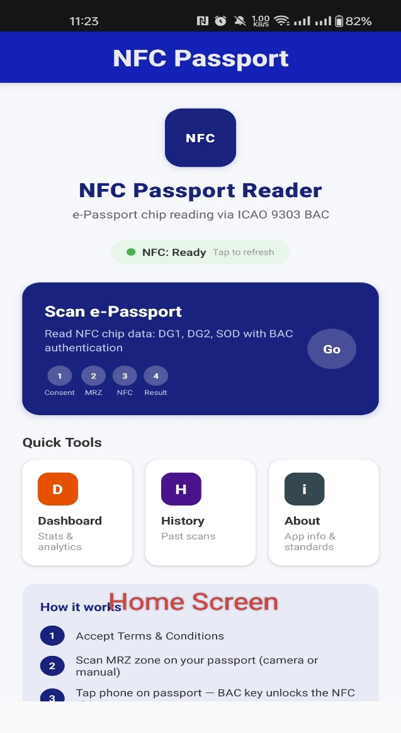
Figure 1 The App home screen
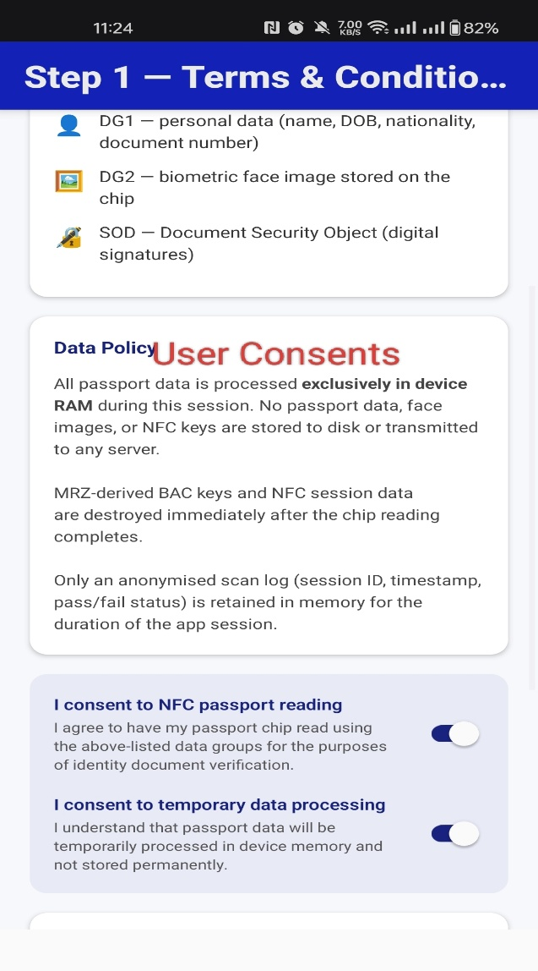
Figure 2 shows the consent screen with both toggles enabled and the four-step scan process outlined.

MRZ Scanning
Once consent is given, the application proceeds to MRZ scanning. The Machine-Readable Zone (MRZ) consists of two lines of 44 characters each, located at the bottom of the passport’s data page. These lines encode the document number, date of birth, date of expiry, nationality, name, and check digits.
The application supports two input modes. Camera Scan (OCR) uses the rear camera to capture the passport data page. Google ML Kit’s text recognition engine reads the MRZ lines in real time, with a yellow alignment guide highlighting the MRZ zone and extracting both lines automatically once aligned. Manual Entry allows the user to type both 44-character MRZ lines directly into the input fields.

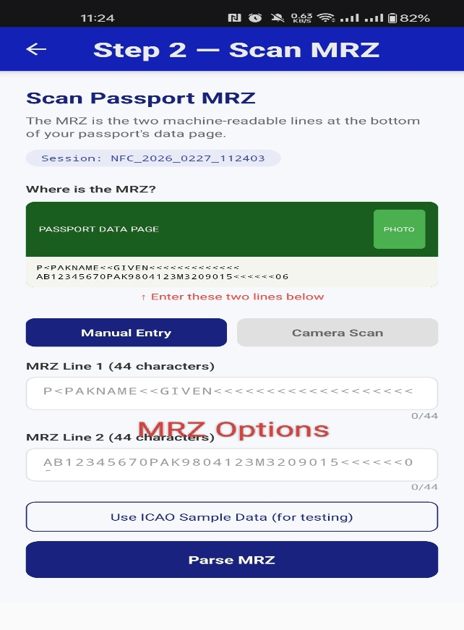
Figure 3 shows the manual entry mode with the sample MRZ format displayed
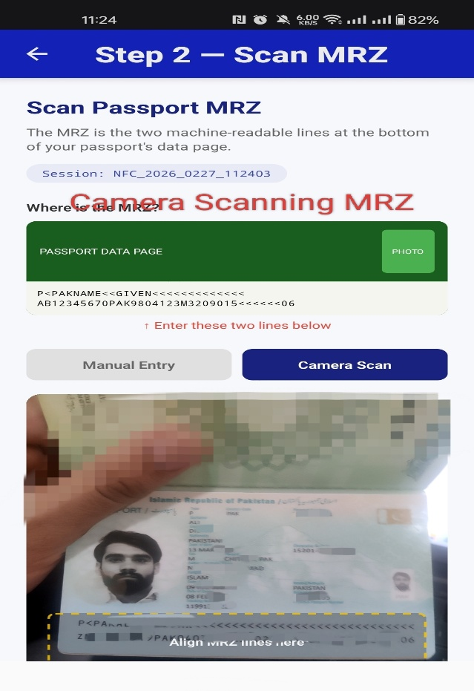
Figure 4 shows the OCR camera scan in progress with the passport aligned to the MRZ zone

Key Derivation (BAC Key Generation)
The MRZ data extracted in Step 2 is used to derive the cryptographic keys required for Basic Access Control (BAC). This ensures that only a party who has physically seen the passport MRZ can unlock and read the NFC chip, a fundamental security control defined in ICAO 9303. The key derivation process proceeds as follows:
- Concatenate document number + check digit, date of birth + check digit, and date of expiry + check digit → form a 24-character MRZ key string.
- Compute SHA-1 hash of this string.
- Take the first 16 bytes of the hash → this becomes the key seed.
- Derive two keys from the seed:
  - Kenc using counter 0x00000001 (encryption key)
  - Kmac using counter 0x00000002 (MAC key)
- Adjust DES parity on all key bytes (each byte must have odd parity for 3DES).
- Store keys temporarily in RAM only.
- Destroy keys immediately after the session ends.
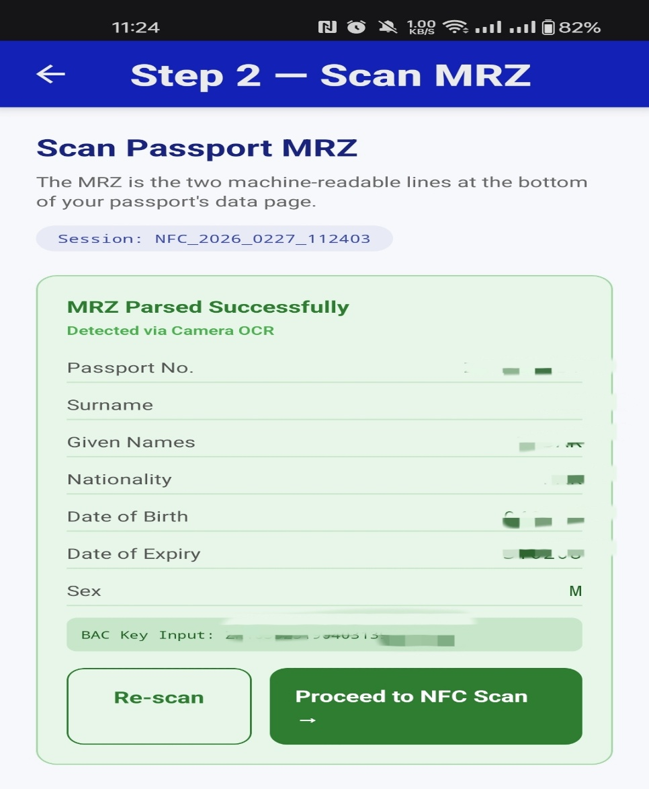
Figure 5 BAC generated from MRZ
.

NFC Tap and Authentication
With the BAC keys derived, the application initiates the NFC session. The user places their phone (back face) against the cover of the passport and holds steady for up to 10 seconds. The authentication sequence proceeds in four stages.
- Application Selection: App sends SELECT APDU with AID A0000002471001; chip confirms.
- Get Challenge: App requests 8-byte nonce (RND.ICC) from chip.
- Mutual Authentication (3DES): App generates RND.IFD, encrypts with Kenc, sends EXTERNAL AUTHENTICATE; chip responds; app verifies → mutual trust established.
- Secure Messaging: Derive session keys (ksEnc, ksMac) and SSC; all APDUs encrypted with 3DES + ISO 9797-1 MAC.
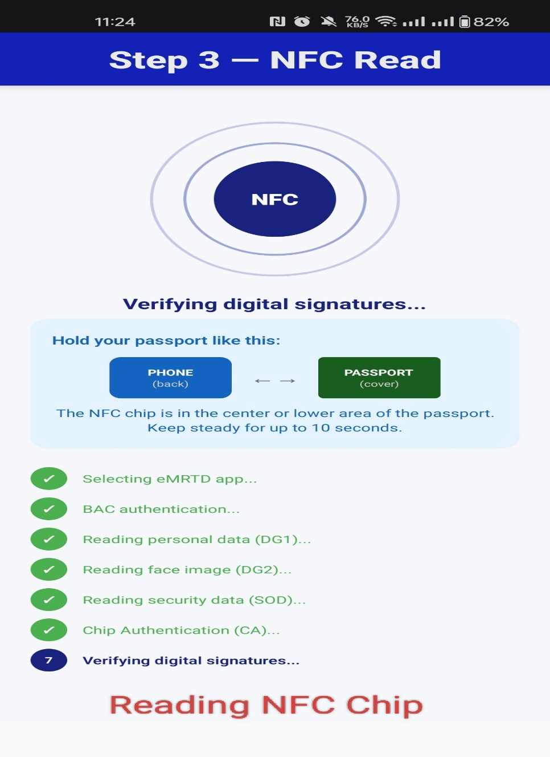
Figure 6 shows the NFC Read screen with completed stages visible
.

Data Extraction (DG1, DG2, SOD)
After the secure session is established, the application reads four data groups from the chip over the encrypted channel: DG1 (Personal Data), DG2 (Face Image), DG14 (Chip Authentication SecurityInfos), and SOD (Security Object Document), using 224-byte chunks via sequential READ BINARY APDU commands.

Verification (Passive Authentication)
After extracting DG1 and DG2, the app performs three verification checks.
  - Passive Authentication (SOD Hash Check)
- Auto-detect hash algorithm from SOD OID (SHA-1, SHA-256, SHA-384, or SHA-512); compute hash of raw DG1 and DG2 bytes read from chip.
- Compare them with the hashes stored in the SOD file.
- If they match → data has not been altered since issuance.
  - CSCA Certificate Validation
- Verify the SOD’s digital signature using the Country Signing CA (CSCA) certificate.
- Parse full ASN.1/CMS SignedData; decode LDSSecurityObject to extract hash algorithm OID and DataGroupHashValues for each data group.
- Full certificate chain validation against the ICAO PKD was not implemented (due to access limitations).
  - Chip Authentication (CA)
- Result: N/A — EC public key stored in EF.CardSecurity on this passport; requires PACE (not available via BAC).
- If the chip returns SW 9000, it holds the genuine EC private key → chip is authentic and not cloned.
- Generate an ephemeral ECDH key pair; send GENERAL AUTHENTICATE with the ephemeral public key over Secure Messaging.
- Read DG14 (SecurityInfos) and parse the chip’s EC public key from SubjectPublicKeyInfo BIT STRING (uncompressed point, 04 prefix).

.
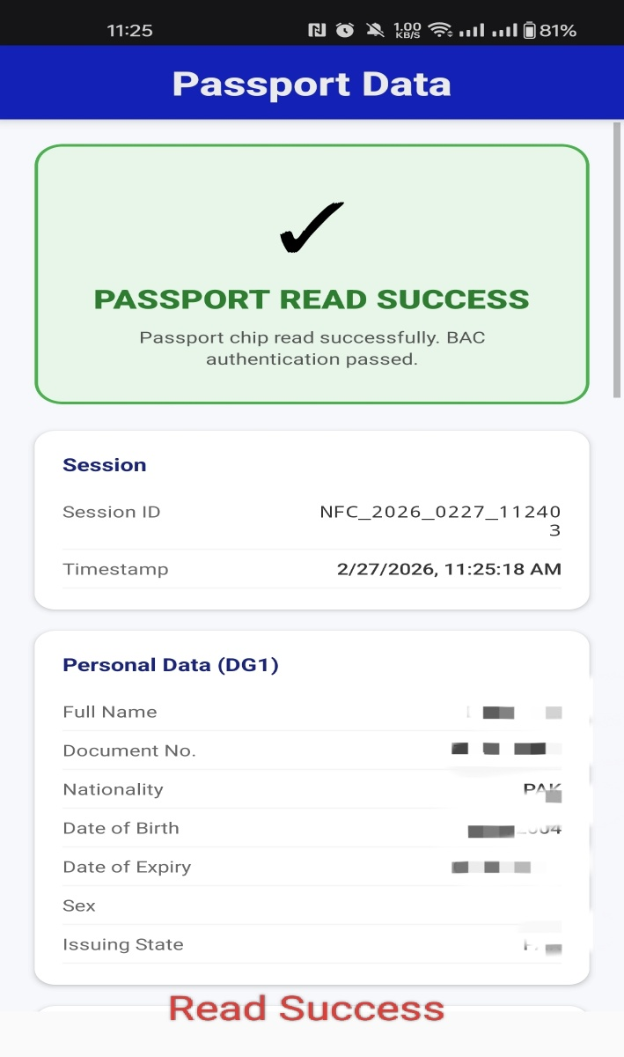
Figure 7 shows the results screen with DG1 (personal information)
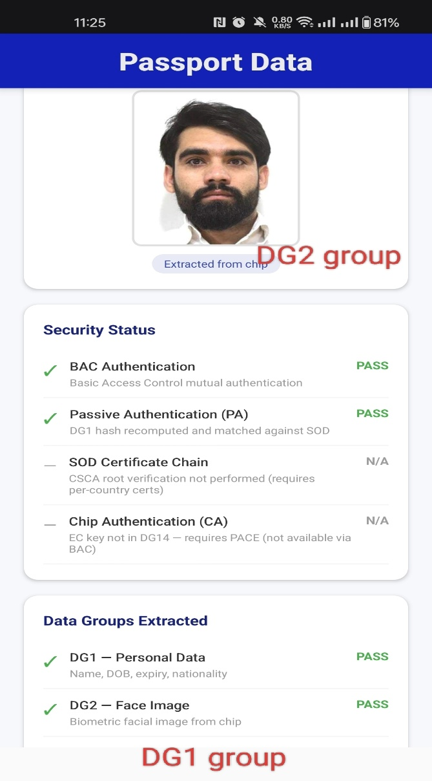
Figure 8 shows the results screen with DG2 and security status

Results Summary
The table below summarizes the outcome of each stage in the demonstration.
Stage | Result
User Consent | Obtained — session ID generated
MRZ Scan (OCR) | Successful — document number, DOB, DOE extracted
Key Derivation (Kenc + Kmac) | Successful — derived via SHA-1 / 3DES
BAC Mutual Authentication | Pass
DG1 — Personal Data | Pass
DG2 — Face Image | Pass
SOD — Security Object | Pass
Passive Authentication (SOD Hash Check) | Pass
Chip Authentication (CA) | N/A — ECDH implemented; EC key in EF.CardSecurity (requires PACE, not available via BAC)
Full CSCA Chain Verification | Partial — DG1/DG2 hash verified via ASN.1/CMS parsing; DSC/CSCA certificate chain not verified
The demonstration confirms that MRZ-derived keys can successfully unlock a Pakistani e-passport NFC chip, and that DG1 personal data, DG2 biometric facial image, and SOD digital signatures can all be extracted and verified using the ICAO 9303 BAC protocol on a standard NFC-enabled Android smartphone, without any specialised hardware beyond an NFC-enabled Android smartphone, and without requiring proprietary software or government-issued certificates for core data extraction and passive authentication.

